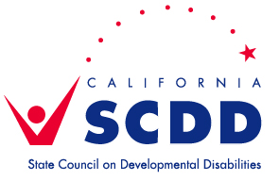 | Sacramento Regional Office  3831 N. Freeway Blvd. Ste. 125, Sacramento, CA 95834  916-263-8134

Schedule for 2022
Sacramento Regional Advisory Committee (RAC)
Due to the Pandemic, until further notice, meetings are held via Zoom. If you would like to be added to our email list to be notified of future meetings, send an email to Sonya.Bingaman@scdd.ca.gov or check on this webpage. Packets are posted at least 10 days in advance of each RAC meeting.
We welcome all to attend.

FEBRUARY
RAC Meeting | Tuesday, February 15, 10am-1pm
APRIL
RAC Meeting | Tuesday, April 19, 10am-1pm
JUNE
RAC Meeting | Tuesday, June 21, 10am-1pm
AUGUST
RAC Meeting | Tuesday, August 16, 10am-1pm
OCTOBER
RAC Meeting | Tuesday, October 18, 10am-1pm
DECEMBER
RAC Meeting | Tuesday, December 20, 10am-1pm

*Please email sonya.bingaman@scdd.ca.gov or call 1-916-263-8134 to confirm dates and locations, in case of changes.
NOTE: RAC members should notify SCDD Sac staff, at least 2 days prior to the meeting, if they are unable to attend.

