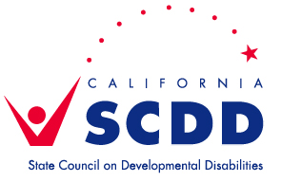 | Sacramento Regional Office  3831 N. Freeway Blvd. Ste. 125, Sacramento, CA 95834  916-715-7057 sacramento@scdd.ca.gov
Regional Advisory Committee (RAC) Schedule for 2021
(all meetings will be on Zoom until further notice. Updates, Agendas, and Packets can be located at https://scdd.ca.gov/sacramento/)

FEBRUARY
RAC Meeting | Tuesday, February 9, 10am-1pm
APRIL
RAC Meeting | Tuesday, April 20, 10am-1pm
JUNE
RAC Meeting | Tuesday, June 15, 10am-1pm
AUGUST
RAC Meeting | Tuesday, August 17, 10am-1pm
OCTOBER
RAC Meeting | Tuesday, October 19, 10am-1pm
DECEMBER
RAC Meeting | Tuesday, December 14, 10am-1pm

NOTE: All are welcome to attend. RAC members should notify SCDD Sac staff, at least 2 days prior to the meeting, if they are unable to attend.

