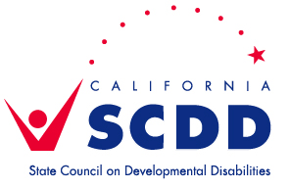
Join the State Council on Developmental Disabilities –
Sacramento Regional Office for our December Zoom Chat
December 8, 2020 ~ 10:00 am - 11:00 am

DREDF (Disability Rights Education and Defense Fund: https://dredf.org/) has been selected as the Parent Training & Information Center for 30 Northern CA Counties and is funded by the US Department of Education to serve families of children and young adults from birth to age 26 with all disabilities: physical, cognitive, emotional, and learning. DREDF now provides services in El Dorado, Nevada, Placer, Sierra, and Sacramento counties. In collaboration with Matrix Parent Network and Resource Center they will offer services in Alpine, Sutter, Yuba, and Yolo counties. They also collaborate with Rowell and Family Soup agencies.

They help families:
- Obtain appropriate education and services for their children with disabilities;
- Work to improve education results for all children;
- Train and inform parents and professionals on a variety of topics;
- Resolve problems between families and schools or other agencies;
- Connect children with disabilities to community resources that address their needs.

Juliet Barraza, Kenya Martinez, Cheryl Thies, and Diana Vega will share about the services and supports offered through DREDF and how to collaborate as they expand their reach to serve this region in the coming months.
Bring your questions and join us for this important discussion!

Please click on this Zoom link to Pre-register. https://bit.ly/3lKygy4
You will then receive an email with your personalized link to the Zoom Training.
.

If you have a question or need an accommodation, please contact Sonya Bingaman at least 5 days in advance of the training at sonya.bingaman@scdd.ca.gov or 916-715-7057. Spanish language simultaneous translation will be provided on Zoom.

Recordings of trainings will be posted at www.youtube.com/CalSCDD.
Recordings are in English, with optional Closed Captioning and language translation available.

