Join the State Council on Developmental Disabilities’ Sacramento Regional Office & Alta California Regional Center for an:

Overview of Home and Community Based Services
(HCBS Final Rule)* and how it relates to Regional Center Services

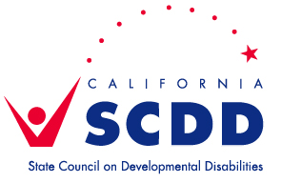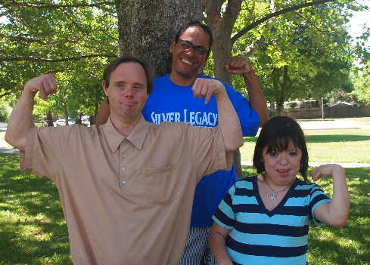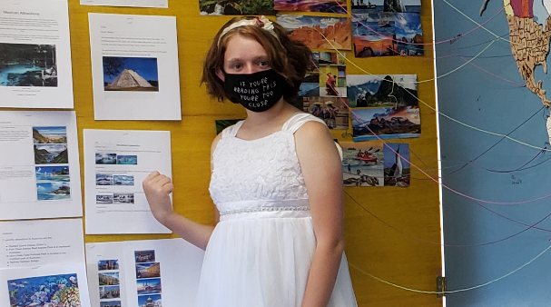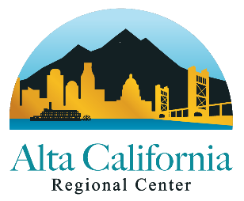

Wednesday, December 2, 2020 ~ 6:00pm-8:00pm
Register for this free Zoom training at: https://bit.ly/30Z37P4

Note: This training is meant for self-advocates/people receiving services through the Regional Center, and their family members/care providers. But all are welcome!

- HCBS is about: community integration, independence, choice, person centered planning & clients’ rights.
- In vendored/licensed residential settings, HCBS outlines: rights to visitors, access to food, lockable doors, choice of single room / choice of roommate, accessibility, and so on.
- Learn how HCBS affects choices of services through the Regional Center?
  - Day & Employment programs
  - Transportation
- Independent Living and Supported Living and more

*What is HCBS? Home and Community-Based Services were developed to offer support to individuals in community settings, as an alternative to institutional care. In 2014, new federal rules were released by the Centers for Medicare & Medicaid Services (CMS), requiring homes and programs where HCBS are delivered to meet new criteria. The Department of Developmental Services (DDS) and its partners are working to implement the requirements for home and community-based settings in accordance with this Final Rule. Most Regional Center clients (and most service providers), will be affected by the CMS Final Rule.

Katherine Weston, Home and Community Based Specialist, Alta California Regional Center, will help us learn more about HCBS.
If you have a question or need any accommodations, please contact Sonya Bingaman at least 5 days in advance at sonya.bingaman@scdd.ca.gov or 916-715-7057. Spanish translation will be provided – please select that when registering.

Recordings of this HCBS training & previous trainings on a variety of topics can be found at www.youtube.com/CalSCDD

