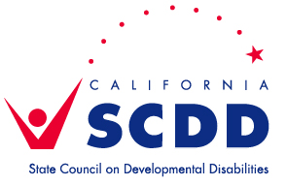 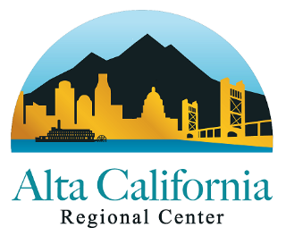

**Let’s celebrate Employment in October**

**Join the SCDD – Sacramento Regional Office & Alta California Regional Center**

**to celebrate National Employment of People with Disabilities Month with a 4-part series.**

Please click on the Zoom link below, now, to Register for each event separately. You will then receive an email with your personalized link to the Zoom Training.

A young man working at a computer



**October 6, 2020 ~** **10-11:30am** **Employment Services from ACRC, Employment First Legislation and Competitive Integrated Employment (CIE)**: Cindy Le, Employment Services Specialist, Alta California Regional Center (ACRC) will discuss Employment Services from ACRC, Employment First Legislation and Competitive Integrated Employment (CIE). Bring your questions and join us for this important discussion.

Register in advance at: <https://bit.ly/2FrLKz0>

**October 13, 2020 ~** **10-11:30am** **DOR Student Services & Career Exploration:** Jose Garcia, Senior Vocational Rehabilitation Counselor-Service Coordinator, Department of Rehabilitation (DOR) will discuss DOR Student Services which help students prepare for workplace success by exploring options, getting ready to work, and creating careers. There are five types of DOR Student Services, which include Job Exploration Counseling, Work-Based Learning Experiences, Postsecondary Counseling, Workplace Readiness Training, and Self-Advocacy Training. Hear what the purpose of each of the five types of DOR Student Services, and examples of the types of things you can do, learn, and explore in each category. You and your DOR staff member may use these examples to identify which activities in your local area match your interests and needs.

**And** Jessica Conant, MS, Disability Resource Coordinator with Golden Sierra Job Training Agency will discuss **Career Exploration**.  Golden Sierra Job Training Agency offers an integrated workforce system that capitalizes on the expertise of industry and workforce partners to continuously meet the needs of business, and facilitate pathways to success for students, workers and job seekers. Golden Sierra offers no-cost employment services and resources to job seekers and employers in Placer, El Dorado and Alpine counties.

Register in advance at: <https://bit.ly/35Nhk4I>

**October 20, 2020 ~** **2-3:30pm (note different time)** **Business Outreach & Benefits Counseling:** Steve Ruder, Program Coordinator at the UC Davis MIND Institute, will discuss the Business Advisory Council (BAC) that supports businesses to give presentations about the process and benefits of hiring people with disabilities who receive assistance from supported employment agencies, American Job Centers, and the Department of Rehabilitation. Businesses share about their experiences and talk about the work their employees do.  Businesses learn how to hire quality employees with disabilities and connect with the agencies that support them. We will also discuss employment services available to people who are and *are not* clients of the regional center.

**And**, Dee Gavaldon, Program Manager and Benefits Counselor, Crossroads, a Pride Industries company, will discuss **Benefits Counseling** including the transition from work activity to community employment and how changes can affect your benefits.

Register in advance at: <https://bit.ly/3ktWmfC>

**October 27, 2020 ~** **10-11:30am** **Let’s celebrate our stories!** A panel of transition aged youth & adults with developmental disabilities, a parent, and job coaches from several supported employment agencies share about their experiences working before and during COVID-19. What supports did they receive that helped them prepare for and get a job, what challenges did they face, what have they learned on the job, how was their job affected during Covid, what new jobs have they found? What advice do they have for others seeking employment?

 Register in advance at: <https://bit.ly/2RC6Vkf>

If you have a question or need an accommodations, please contact Sonya Bingaman at least 5 days in advance of the training at [sonya.bingaman@scdd.ca.gov](mailto:sonya.bingaman@scdd.ca.gov) or 916-715-7057.

Recordings of trainings will be posted at [www.youtube.com/CalSCDD](http://www.youtube.com/CalSCDD)

**[](https://progressiveemployment.org/)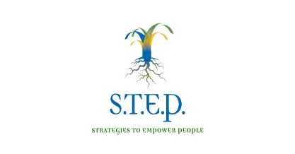 Pride Industries logo**

 **[Dept of Rehabilitation Logo](https://www.dor.ca.gov/)** 

