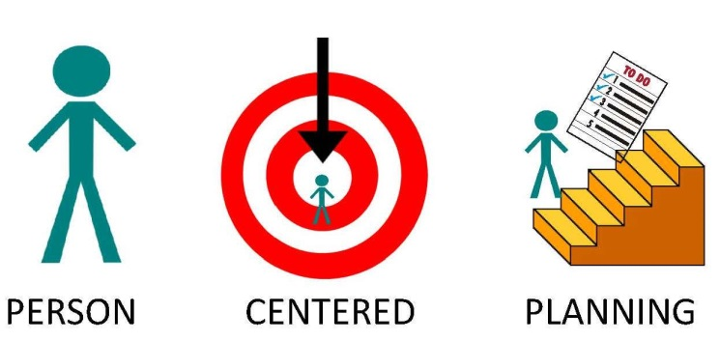
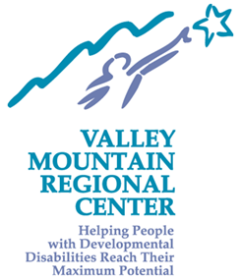

Join us at one of the Person Centered Planning & Thinking Trainings
Presented by VMRC staff

OPEN TO ALL!

VMRC Stockton Office VMRC Modesto Office
702 North Aurora Street 1820 Blue Gum Avenue
Stockton, CA 95202 Modesto, CA 95358
209-473-0951 209-529-2626
TIMES: 9am-4pm TIMES: 9am-4pm

- February 21 and 22 (Thursday and Friday)  - April 24 and 25 (Wednesday and Thursday)  - June 3 and 4 (Monday and Tuesday)  - August 22 and 23 (Thursday and Friday)  - October 30 and 31 (Wednesday and Thursday)  Tentative DATE only if needed:  December 5 and 6 (Thursday and Friday) | - January 29 and 30 (Tuesday and Wednesday)  - March 28 and 29 (Thursday and Friday)  - May 16 and 17 (Thursday and Friday)  - July 22 and 23 (Monday and Tuesday)  - September 25 and 26 (Wednesday and Thursday)  Tentative DATE only if needed:  November 14 and 15 (Thursday and Friday)

