Where People Are Served

This page shows average number of regional center consumers receiving services statewide. In the last eight years, fewer people are in individual placement supported employment, which is integrated competitive employment. There are 1,100 more people in group supported employment, while fewer and fewer people are choosing sheltered work. Day and look alike day programs have increased a lot, by over 15,000 people.
Many day and look alike programs offer limited work experience to their clients. However, there is no data on how many clients work through these programs, how many hours a week they work, or what their hourly earnings are.
What this page shows us: Even though people want to work, and we know how to support them to work, the vast majority of service growth has been largely non-work programs. This means that most people who become adults go into non-work programs instead of employment services.

Table 1. Where People are Served (2005-20013)

Fiscal Year | Supported Employment Programs Individual | Supported Employment Programs Group | WAP | Day & Look Alike Programs
05/06 | 4,842 | 4,548 | 11,988 | 44,280
06/07 | 4,976 | 5,264 | 11,499 | 46,120
07/08 | 5,004 | 5,623 | 11,063 | 48,290
08/09 | 5,065 | 5,863 | 11,110 | 51,067
09/10 | 4,841 | 5,903 | 10,826 | 53,056
10/11 | 4,684 | 5,932 | 10,610 | 54,387
11/12 | 4,505 | 5,425 | 10,293 | 56,749
12/13 | 4,341 | 5,589 | 10,242 | 59,661

This page displays the data three ways:

- The table above shows the numbers over the past three years.
- The bar chart below shows how many people are in each service type, with the integrated employment options being a relatively small number at the bottom.
- The line chart below shows that integrated employment options are not going up, sheltered work is going down slowly, and day and look alike programs are increasing rapidly. Therefore, all the growth in working age day services is being absorbed by day and look alike programs.

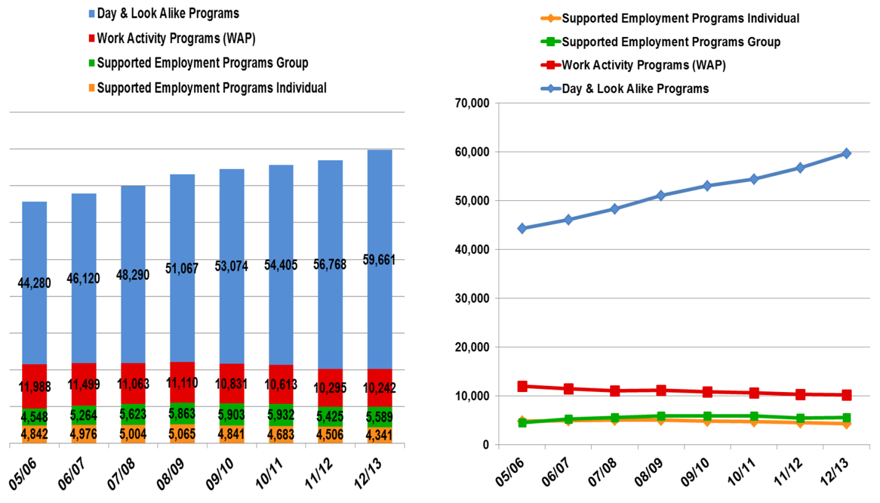

DATA SOURCE: Footnote DDS Purchase of Service (POS) system Hab Transition with Synthetic Waiver FY 05/06-07/08, and Habilitation transition 08/09-12/13. End of Footnote

