Valley Mountain Regional Center’s
Self-Determination Advisory Committee
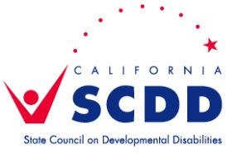
MINUTES
June 30, 2015
Members Present: Members Absent
Bob Enyeart Jayme Flores
Crystal Enyeart Bethany Mickahail
Claire Lazaro
Gia McElroy VMRC Staff
Al Mickahail Paul Billodeau
Lisa Utsey Cindy Mix
Leinani Walter Angie Shear
Liz Zastrow SCDD Staff
Dena Hernandez

- Paul called the meeting to order at 3:05pm
- Welcome and Introductions- everyone introduced themselves. Each member received a folder with the agenda and other information on Self Determination.
- Power Point Training- Dena reviewed the power point training for Self Determination Advisory Committees. Committee members asked that this presentation be emailed to them. Dena will send it out. The following was the information shared on the power point:
Self-Determination
-What it is, how it works, roles, and related issues
Role of the Self-Determination Advisory Committees
Statewide SDAC
DDS SD Workgroup
SDAC Dynamics
Miscellaneous issues such as parliamentary procedure, meeting schedule, etc.
Possible issues for the SDACs to initially tackle
Anticipated challenges
- Questions/Comments- Dena will email two other power points with Self Determination information to members. Members were encouraged to sing up for email alerts op the DDS website (dds.ca.gov). Many questions regarding the facilitator and fiscal roles for this program. Info will be researched.
- Next Meeting- Tuesday, September 29, 2015 at VMRC Stockton Office- 3pm-4pm

