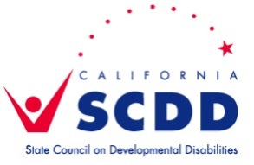

Self Determination Advisory Committee (SDAC)
June 30, 2015
3pm-4pm
Valley Mountain Regional Center
AGENDA

Introductions- all
Power Point Training- Paul & Dena
- Self-Determination
-What it is, how it works, roles, and related issues
- Role of the Self-Determination Advisory Committees
- Statewide SDAC
- DDS SD Workgroup
- SDAC Dynamics
- Miscellaneous issues such as parliamentary procedure, meeting schedule, etc.
- Possible issues for the SDACs to initially tackle
- Anticipated challenges

Questions/Comments- all
Next Meeting-
Tuesday, September 29, 2015 at VMRC Stockton Office- 3pm-4pm

