ANNOUNCING…..
Space is limited
sign up early

A FREE LEADERSHIP SYMPOSIUM FOR people who are interested in IMPROVING THEIR KNOWLEDGE OF HEALTH AND WELLNESS.

This training for self advocates will be held on September 30th from 3:30p.m. - 7:00p.m.

The training will be both work and fun. During the training we will focus our discussion on Mind and Body. Together we will learn about topics such as:
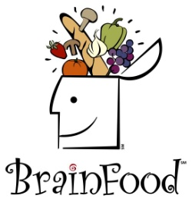
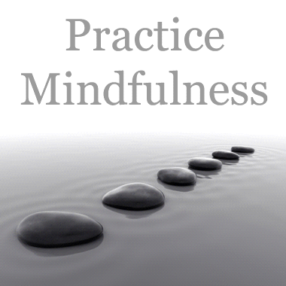

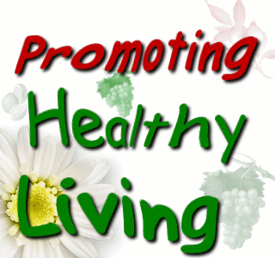

Please join us as we learn more about how to keep ourselves healthy.….

For information call Salome at (760)352-2236. Application deadline for participation in the training is September 19, 2016. The training will be held in the conference room at the ARC, 298 E. Ross Ave. El Centro, CA 92243

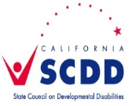

Leadership Symposium
September 30, 2016
3:30- 7:00

NAME:_________________________________________________________

ADDRESS:______________________________________________________

CITY:_______________________STATE_____________ZIP_______________

TELEPHONE:(_____)______________________________________________

YOUR AGENCY, WORKPLACE OR DAY PROGRAM:____________________

PLEASE CHECK: Wheelchair User ____Yes____No
_____Consumer_____Parent_____Attendant_____Professional_____Other

Language Preferred: __ English __ Spanish __ Other (please Specify)

Transportation needed: ___Yes ___ No

List any special assistance you need:

_______________________________________________________________

_______________________________________________________________

All supervision, medical and personal care needs are the responsibility of each conference participant. A support person must accompany individuals needing special assistance or supervision

FORMS ARE DUE BY FRIDAY, September 19, 2016.
Questions? Call Salome at (760)352-2236.

Return forms to:
Salome White
Arc Imperial Valley
P.O. Box 1828
El Centro, CA 92244

