How Many Earned Wages

What this page shows us: This page shows how many working age regional center clients have earned money in each of the last seven years. The number of people making money has gone up slightly over time, interrupted by the great recession in 2009 and 2010. However, in 2012 the number of people making money was back down to the level of the recession. Also, the percentage of working age regional center clients who do make money is still very small, only 12.4% in 2012. Even though the number of people with earnings is increasing slowly, the number of working age regional center clients has also been increasing.

Table 1. Average Number of Consumers Receiving Wages

Year | Average Number of Consumers Receiving Wages
2005 | 15,687
2006 | 15,864
2007 | 16,335
2008 | 17,346
2009 | 17,142
2010 | 17,242
2011 | 17,870
2012 | 17,238

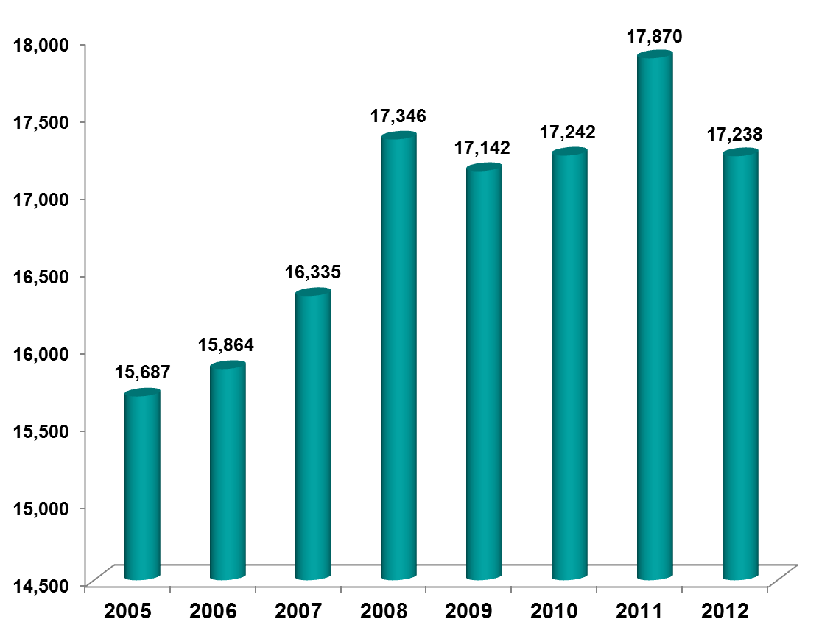

Footnote: The data is from Employment Development Department (EDD). California EDD data reflects the average number of consumers reporting to EDD for the purpose of Unemployment Insurance, a limitation of the data as some people have contract earnings that are unreported. End of footnote..

