Employment Rates (2011)

What this page shows us: The employment rate of people with disabilities is far behind the employment rate for people without disabilities; and the employment rate for people with developmental disabilities is far behind the rate for people with all types of disabilities.

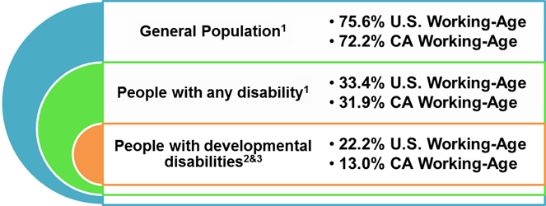
**Please see footnotes for Working-Age
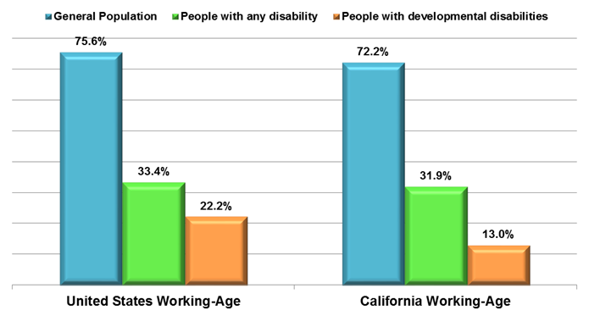
1 The data is from the 2011 Disability Status Report, United States, by Cornell University, based on analysis of the US Census Bureau's, American Community Survey (ACS), page 8. The data reflects non-institutionalized working-age people (21-64) with disabilities who work full-time/full year in the United States. The six types of disabilities included in the data are: sensory, physical, mental, self-care, go-outside-home, and employment.
2 The data is from National Population Statistics, page 57, Table 2 (22.2%). Employment Participation for Working-Age People (Ages 16 to 64), State Data: The National Report on Employment Services and Outcomes 2012 published by the Institute for Community Inclusion, UMASS. The data reflects individuals with cognitive disability employed in the United States.
3 The data is from Employment Development Department (EDD). CA EDD Data (13%) reflects wages reported to EDD for the purpose of Unemployment Insurance reporting, a limitation of the data as some people have contract earnings that are unreported.

California Employment Rates

Year | General Population1 | People with Any Disability1 | People with Developmental Disabilities
2008 | 77.3% | 37.2% | 13.4%
2009 | 74.3% | 34.2% | 13.4%
2010 | 72.1% | 32.3% | 13.1%
2011 | 72.2% | 31.9% | 13.0%

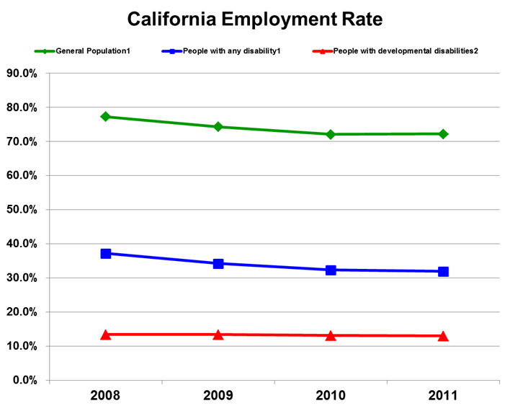

1The data is from the 2008-2011 Disability Status Report, California, by Cornell University, based on analysis of the US Census Bureau's, American Community Survey (ACS), pages 32 for 2008, 31 for 2009-2011. The data reflects non-institutionalized working-age people (21-64) with/without disabilities working in California. The six types of disabilities included in the data are: sensory, physical, mental, self-care, go-outside-home, and employment.
2The data is from the Employment Development Department (EDD). California EDD data reflects wages reported to EDD for the purpose of Unemployment Insurance reporting, a limitation of the data as some people have contract earnings that are unreported.

