Employment Rates (2010)

The yearly analysis from Cornell University of working age (21-64) people with disabilities, compared to those without, provides the opportunity to measure California results to the United States. The University of Massachusetts, Boston, StateData report provides a statistical analysis of US individuals with cognitive disability working age (16-64) who are employed. Using the data collected from California Department of Employment (EDD), California Department of Developmental Services (DDS) compares California to the US results to get a fair measurement of the disability employment rate.

This cell is null | United States Working-Age | California Working-Age
General Population ¹ | 75.4% | 72.1%
People with any disabilities | 33.9% | 32.3%
People with developmental disabilities | 22.8% ² | 13.0% ³

**Please see footnotes for Working-Age

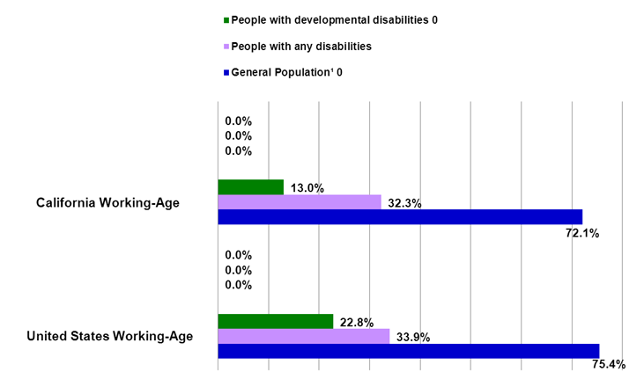

¹ The data was supplied by Erickson William, Research Specialist of Cornell University, based on analysis of the US Census Bureau's 2010 American Community Survey (ACS) Public Use Micro Data Sample (PUMS). The data reflects non-institutionalized working-age people (21-64) with disabilities who work full-time/full year in the United States. The six types of disabilities included in the data are: sensory, physical, mental, self-care, go-outside-home, and employment.
² The data is from National Population Statistics Table 2 (22.8%): Employment Participation for Working-Age People (Ages 16 to 64), State Data: The National Report on Employment Services and Outcomes 2011 published by the Institute for Community Inclusion, UMASS. The data reflects individuals with cognitive disability employed in the United States.
³ The data is from Employment Development Department (EDD). CA EDD Data (13%) reflects wages reported to EDD for the purpose of Unemployment Insurance reporting, a limitation of the data as some people have contract earnings that are unreported.

