Education Data

For June 30, 2013, the California Department of Education reports that 5,849 students with significant disabilities (autism, intellectual disabilities and traumatic brain injury) left K-12 education. Of those, 32% graduated, 24% received a certificate of completion, and 44% either dropped out or aged out. The table below shows more details, including the different ways a student can graduate high school with a diploma or equivalent and the ways students leave school without completion.
What this page shows us: Most students with significant disabilities are struggling to complete high school. Of those students who graduated, most had autism, and very few had an intellectual disability. Most of those with certificate of completion had an intellectual disability.
More than half of students with an intellectual disability either dropped out or aged out. Finishing high school is a requirement for many entry level jobs.

2012 - 2013 Academic Year | Autism | Intellectual Disability | Traumatic Brain  Injury | Totals
Grad. high school with regular diploma | 1,126 | 203 | 69 | 1,398
Received high school completion (GED) | 6 | 12 | 0 | 18
Grad. High school with diploma using exemption | 188 | 133 | 21 | 342
Grad. High school with a diploma using waiver | 58 | 31 | 7 | 96
Graduated Subtotal | 1,378 | 379 | 97 | 1,854
Grad. high school with certificate of completion | 392 | 993 | 24 | 1,409
Completed Subtotal | 392 | 993 | 24 | 1,409
Reached maximum age (22) | 366 | 987 | 16 | 1,369
Dropped out | 294 | 300 | 24 | 618
Parent/self-withdrawal if over 18 | 362 | 226 | 11 | 599
Incomplete Subtotal | 1,022 | 1,513 | 51 | 2,586
Totals | 2,792 | 2,885 | 172 | 5,849
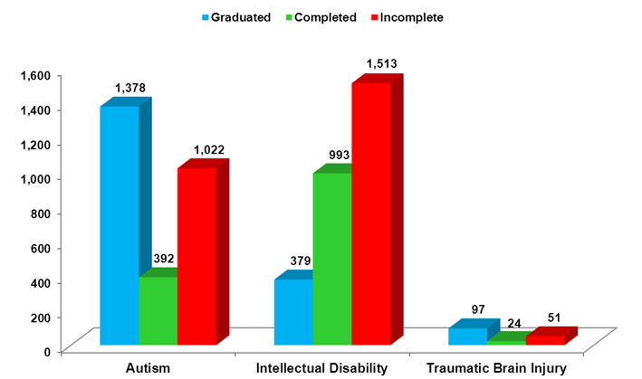

DATA SOURCE: The California Department of Education (CDE) provides special educational services to children with disabilities meeting their unique needs, in the least restrictive environment. Required by the Individuals with Disabilities Education Act (IDEA) and Elementary and Secondary Education Act (ESEA), all students must be included in the statewide assessment and accountability system. CDE developed and implement alternate performance assessment for disabled children who could not take part in the general “California Standards Tests”. CDE along with other state agencies provide help preparing disabled children and young adults’ transition from school to employment and a quality adult life. Graduating high school is essential for improving employment opportunities and lifestyles for disabled young adults.

