California Employment Rates

What this page shows us: The California employment rate of people with disabilities is far behind the employment rate for people without disabilities; and the employment rate for people with developmental disabilities is far behind the rate for people with all types of disabilities. In 2012, the employment rates for the general poputlation and people with disabilities have started to go up after the recession. However, the employent rate for people with disabilities is still going down. Click here to view CA employment Rates vs. U.S. Employment Rates (2012)

Table 1: Table of California Employment Rates, General Population vs. People with Any Disability vs. People with Developmental Disabilities.

Year | General Population1 | People With Any Disability1 | People With Developmental Disabilities2
2008 | 77.3% | 37.2% | 13.4%
2009 | 74.3% | 34.2% | 13.4%
2010 | 72.1% | 32.3% | 13.1%
2011 | 72.2% | 31.9% | 13.0%
2012 | 73.1% | 32.2% | 12.4%

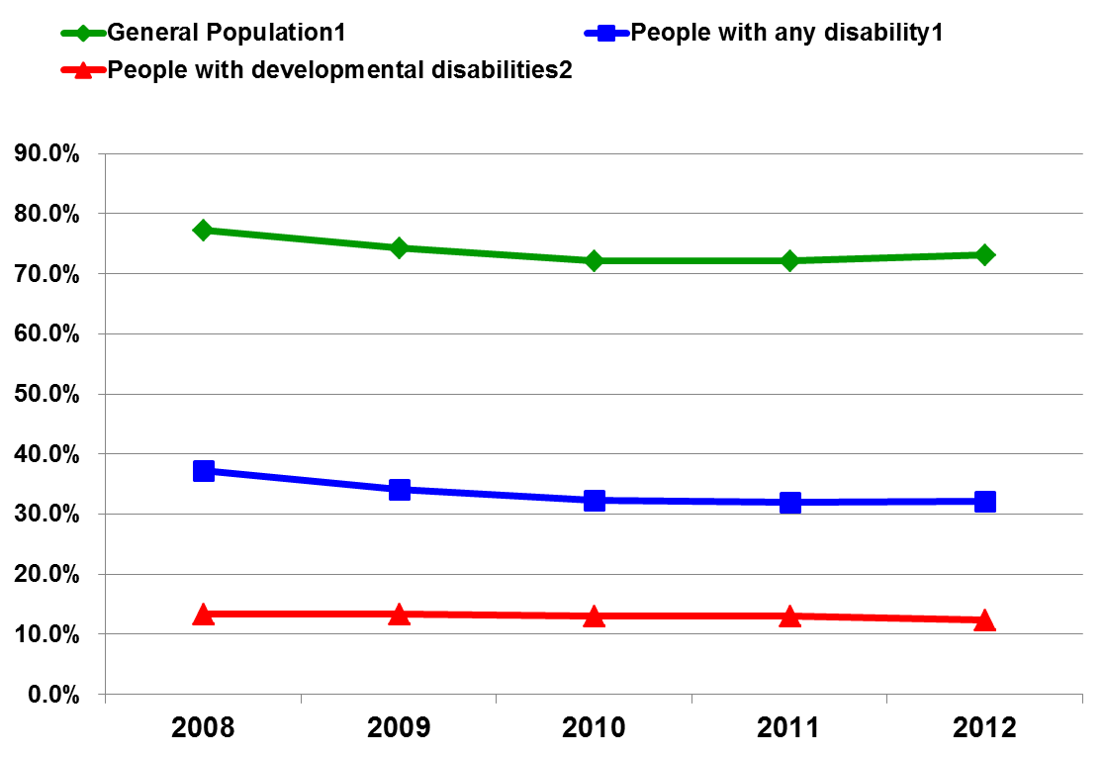

1The data is from the 2008-2012 Disability Status Report, California, by Cornell University, based on analysis of the US Census Bureau's, American Community Survey (ACS), pages 32 for 2008, 31 for 2009-2012. The data reflects non-institutionalized working-age people (21-64) with/without disabilities working in California. The six types of disabilities included in the data are: sensory, physical, mental, self-care, go-outside-home, and employment.

2The data is from the Employment Development Department (EDD). California EDD data reflects wages reported to EDD for the purpose of Unemployment Insurance reporting, a limitation of the data as some people have contract earnings that are unreported. End of Footnote

