Average Monthly Earnings

For those regional center clients who did receive a pay check, the table and chart below shows their average monthly earnings over the last eight years.

What this page shows us: Even regional center consumers who are making money appear to be under-employed, as their average earnings are very low.

The great recession had its biggest impact on working age regional center clients, not in how many had jobs, but in how much they made. While many kept jobs, on average they either worked fewer hours or were paid less.

The bar chart shows that wages went up at first, and then went back down during the great recession. Wages have increased again in the last year. Since these figures are NOT adjusted for inflation, on average their earning power has decreased over time.

Table 1. Average Monthly Consumer Wages

Year | Average Monthly  Consumer Wages
2005 | $487
2006 | $492
2007 | $527
2008 | $508
2009 | $499
2010 | $502
2011 | $485
2012 | $523
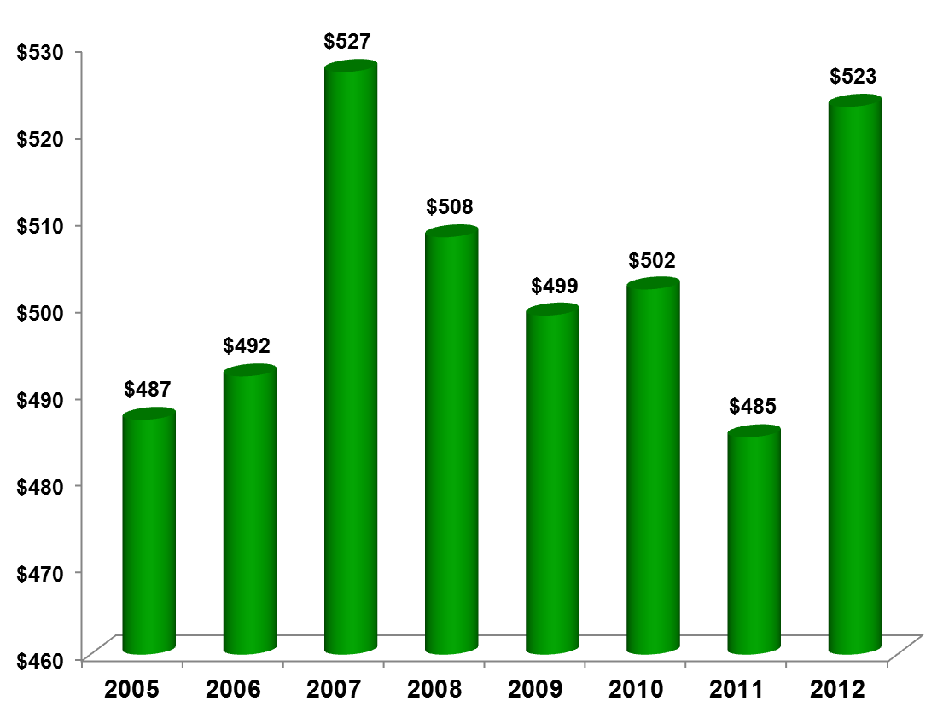

DATA SOURCE: Employment Development Department (EDD) in conjunction with California Department of Developmental Services (DDS) identify consumers who have had employer reported earnings. The EDD data helps DDS measure the number consumers utilizing services each year to begin or maintain employment, plus their earnings. Consumers with contract agreement are not covered by unemployment insurance. Therefore their earnings are not included in the EDD data, due to employers not being required to report contract earnings to EDD.

